TEAM “MELON”
Project Documentation
Table of Contents


- Team Members
All active members of team “Melon” are listed in the table below (in alphabetical order).
Name | Student System Username
Владимир Воев | vladovv
Владимир Петров | vladi17
Симеон Цветков | STzvetkov
Стефан Арнаудов | Arnaudov_St

- Project Description
Our team decided to implement a computer version of the popular board game Carcassonne. The GUI is based on MonoGame. It is a hot seat turn based game where the players consecutively draw a game tile from the stack with not yet played ones then place it on the board/table, taking into consideration the already placed tiles and the rules for neighboring such. On each tile drawn an illusory part of the map of the french castle Carcassonne and its vicinity.
Then the player can put a “soldier” or “farmer” on the so placed tile, reserving part of a road, castle, fields, or a monastery. The goal of the game is to build complete roads, castles and fields which provided given number of points. In the final result also takes part the fields that border with complete castles. The game even if easy to learn is hard to master and requires strategic thinking and limit resources management.
The game’s design follows the main concepts of the object-oriented programming. There is a corresponding class for each object from the real world: tile, pawn (soldier a nd farmer), map, player, etc. Some basic inheritance is implemented.
The main functionalities which have been implemented are:
- visualizing the game board, tiles, pawns, result;
- drawing out a tile, rotating it and placing it on the board;
- performing logical checks for correct moves;
- calculating result
- For more detailed information on the project’s architecture please refer to 2.3: Technical documentation.
- Technical documentation (classes and their responsibilities)
    - class Game

- Class diagram
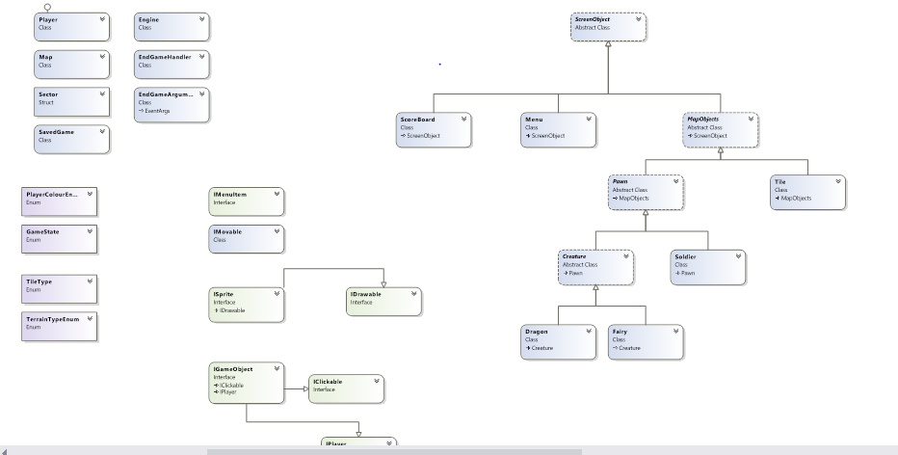
- GitHub Repository
This is the URL of our GitHub repository (Project “Troll-runner”):
https://github.com/STzvetkov/Melon

